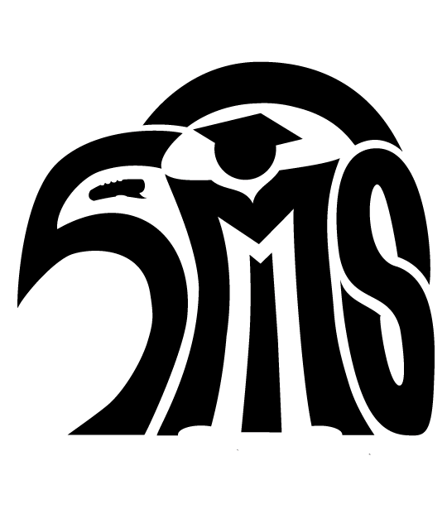
Skyview Expectations and Policies
2018-19

Campus and Classroom Expectations
The following is a condensed list of expectations, which apply to students attending Skyview Middle School. Detailed rules can be found in the Northshore School District Student Rights and Responsibility Handbook at https://www1.nsd.org/resources/reference/rights-responsibilities. Teachers have individual classroom rules in addition to campus expectations.

- Student will be respectful to self, peers and staff, and will comply with school staff directions and requests. All students will come prepared, on time, and ready to learn.
- Skyview is a closed campus. Students are to remain within the boundaries of the school. No adult or student guests are allowed on campus without prior permission. Students arriving late or leaving early must have permission and report directly to the attendance office. Students out of class must have a pass.
- Students are expected to avoid inappropriate physical contact, foul language and dangerous behavior. This includes running, pushing and play fighting. Any form of verbal or physical harassment, bullying, or violence will not be tolerated. Students will notify a staff member if they witness any unsafe or disrespectful behavior. Students will not encourage or promote harassment, fighting or unsafe activities.
- Student dress should be compatible with an educational setting—rather than an off-campus social setting. Students may express individuality in their dress and grooming as long as their appearance does not cause or have the potential to cause a disruption to the educational process for themselves, other students, or staff. If a student’s dress or appearance is such that it constitutes a threat to the health or safety of others, is not suitable to the norms of an educational setting, or otherwise violates the Skyview Middle School dress code, the principal or the principal’s designee may require the student to change his or her dress. A second or repeated violation of this policy may result in disciplinary action in accordance with school policy and procedures. For specifics on the dress code, including a graphic representation, see the Skyview website under the “Students” tab or the 2018-19 Skyview Student Planner.
- No food or drink allowed in the academic hallways, library, computer lab, or gym. No gum chewing at any time.
- Backpacks are not allowed in classrooms, cafeteria or gym unless authorized by a teacher. Lockers are assigned to individual students and are not to be shared or changed. Lockers must by fully locked and not “rigged”. Please do not tape, glue or attach any items to the inside or outside of lockers.
- Students may not use bicycles, skateboards, hoverboards, roller blades, scooters, etc. on campus. Bicycles ridden to school must be locked in the Bike Rack. Students must wear a bike helmet.
- Students must be off campus immediately after school unless supervised by a coach or staff member .
- All campus standards and expectations also apply before and after school.
- Each family and student will read Skyview’s Student Handbook and understand its contents. This document can be found on our website and in the Student Planner.

Cafeteria Expectations
- Proceed through the serving area in an orderly manner. No cuts allowed.
- All items must be paid for before being opened or eaten and before leaving the cashier/kitchen area of the cafeteria.
- Food and drink must be consumed while seated in the lunchroom. No food or drink is allowed outside.
- During lunchtime, students must remain within the yellow boundary lines. Students may not enter the academic building, gym, fields, or ramp.
- Leave a clean space. Pick up your litter, trays, etc. and use our recycling center for disposal.

I certify that I understand the Skyview Expectations and the Northshore School District Rights and Responsibilities Handbook Concerning Student Conduct which is on the Skyview Middle School Website at: https://www1.nsd.org/resources/reference/rights-responsibilities

Student Name ____________________________________________________ Grade ____________________

Student Signature _________________________________________________ Date _____________________
I have read and reviewed these expectations with my student.

Parent Signature __________________________________________________ Date _____________________

