Hello Skyview Families!
In this edition of the Skyview Family Newsletter, you will see:
- Important Upcoming Dates
- Information for Parents
- ASB School News
- National Junior Honor Society
- Heart and Sole - Girls on the Run Program
- Notes from the Nurse
- PTSA News

Important Upcoming Dates
- 3/11: New Start time and bell schedules
- 3/13: Full day 1-6 non-block Wednesday
- 3/13: Band Concerts @ SMS, Choir concert @ NCHS
- 3/19: SMS + Elementary Strings Pathways Strings Concert @ Canyon Creek
- 3/20: PTSA Dine Out (see below for details)
- 3/20: Early Release Wednesday
- 3/21: Final After-School EARN day community service opportunity (see below for details)
- 3/27: Orchestra Concert @ NPAC (All grades)

- Did you know our daily announcements are online? You can find the daily bulletin on the Skyview website and subscribe to receive the daily announcements every day. Click here for the link to the daily announcements.
- Due to the change in school calendar for the snow days, we will start school at 8:10 am every day for the remainder of the school year. The warning bell will ring at 8:05 am and all students will need to be in class by 8:10 am.

ASB News
4th Season Sports
FamilyID Registration opens on March 8th for 4th season sports, which include Track (no cut), 6th grade Volleyball (no cut), 7th & 8th Grade Girls Tennis, 7th & 8th grade Boys & Girls Soccer. All student athletes need to be registered online at familyid.com and have a current sports physical on file.
Yearbooks
The window for yearbook sales is closed. Yearbooks will be available to order during the last two weeks of school.

Skyview Middle School National Junior Honor Society
Skyview Middle School Honor Society recognizes students with exemplary academic achievement, citizenship, leadership, and community involvement. In addition to meeting all of the core requirements, students must apply each school year in order to be considered for annual membership. Students accepted into Honor Society will be invited via acceptance letter to a formal induction ceremony in May.

The application for the 2018-2019 school year and much more information can be found here on the Skyview Website. Completed applications are due by 3:00 PM on March 29th, 2019 to Ms. Subcleff's box in the main office. NO incomplete or late applications will be considered. NO exceptions.

E.A.R.N. Day Information
Students are required to attend one Skyview Community Service Opportunity. The following are the opportunities that have occurred this school year. Please note there is only one opportunity left.
- March 21, 2019 (FINAL after school opportunity): registration is open; registration closes on March 14 at 8 AM

Heart & Sole is Girls on the Run’s program for middle school girls! Heart & Sole creates a positive, structured space for middle school girls to learn about themselves, explore new ideas, cultivate empathy, strengthen connections and develop life skills that will help them as they move through adolescence and beyond.
The Heart & Sole curriculum is rich with themes girls can relate to, addressing the whole girl—body, brain, heart, spirit and social connection—and building important life skills such as team building, developing a support system, boundary setting, decision making, asking for and providing help and more.

Looking for Runners! Ready for your 6th-8th grader to join our Skyview Girls on the Run Team?

- 10 weeks of practices will be held afterschool Tue & Thu beginning March 12th. The celebratory 5k will be on Saturday, June 1st.

Visit https://www.girlsontherunsnoco.org/Register-Now to register.

Please contact Nicole Maleki: nmaleki@nsd.org if you have any questions or need assistance with registration.

A Note from the Nurse
I often hear from our students “I barely slept last night” or “I was up so late”, along with their request to rest in the health room. Our kids have so much going on these days, that a lot of the time they (and we!) sacrifice sleep in order to make time for the other extracurriculars. I wanted to review some information about sleep so that we can assist our students in prioritizing such an important part of their day:
It is important for parents to help students get the sleep they need and to maintain a regular sleep schedule. A good sleep schedule includes going to bed and getting up at the at the same time each day, including the week-end with only the occasional 1-2 hour late wake-up time on week-end mornings. The recommended amount of sleep for children in grades six through nine is 9 hours per night. Having a bedtime routine is important regardless of age.
- Talk with your student about spending 15-30 minutes before bedtime participating in calm soothing activities, such as listening to relaxing music or reading.
- Avoid having beverages containing caffeine, such as coke, 4-6 hours before bedtime.
- Only use your bed for sleeping. If your student does homework or watches TV in bed their body won’t associate lying in bed with sleep. In fact most experts recommend not having TV’s in children’s bedrooms.
- Have a light snack before bedtime.
- Make sure your bedroom and bed are quiet and comfortable, keeping the room temperature cooler and using enough blankets to stay warm.
Planning for and getting enough time to sleep helps prevent illness by boosting our immune system. Sleep also supports academic success for your student. Lack of sleep affects learning because tired students have shorter attention spans, difficulty staying on task, difficulty with memory skills and difficulty with problem solving
If your student continues to wake tired, the problem may be from a lack of quality sleep causing sleep deprivation. This can be caused by sleep apnea. There are daytime and nighttime symptoms of sleep apnea to be aware of.
Nighttime: Daytime:
Snoring Hyperactivity
Breathing pauses during sleep Inattention
Restless sleep Behavior problems
Mouth breathing Sleepiness
If you suspect your student has any of these symptoms contact your healthcare provider.
For more information on sleep go to www.sleepfoundation.org.
As always please call me if you have any questions or concerns.
Jennifer Celms RN, BSN 425-408-6806
jcelms@nsd.org

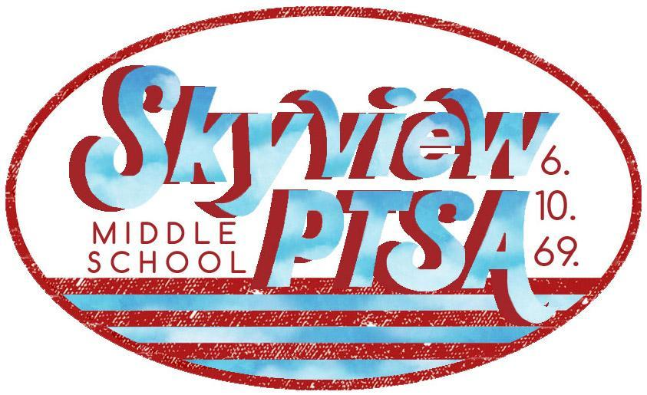 PTSA News
http://skyviewjuniorhigh.ourschoolpages.com/Home
DINE OUT – CHAAT HOUSE
- Wednesday, March 20th, 11:30am – 9:30pm
- Bothell Chaat House – 22612 Bothell Everett Hwy
- Come dine out and enjoy a Skyview community night with friends!
- Mention Skyview PTSA and Chaat House will donate a portion of your meal bill to PTSA.
- Thanks to Bothell Chaat House for hosting the Skyview community!
HOW ARE WE DOING?
- Could you please take a moment and do this quick survey to let us know how we are doing, what we can do to improve, and give us input?
- This feedback is invaluable and we greatly appreciate hearing your voice!
- Click here to begin the survey

SPELLING BEE RESULTS
- Thanks & congratulations to all the participants who took part in Skyview's 1st ever Spelling Bee!
- All the students put many hours into studying, memorizing & practicing hundreds of words! They can all be very proud of their hard work & determination!
- 1st Place: Tarun Krishnamurthy - 6th grade Congratulations! We wish you luck in the Regional Spelling Bee!
- 2nd place: Sushmita Musunuri - 7th grade
- 3rd place: Anvi Karpoor - 6th grade
JOIN THE SKYVIEW TEAM FOR THE CAN DO 5K!
- Saturday April 27, 2019 - 19200 120th Ave NE Bothell, 98011
- Grab a friend and your running shoes!
- The Can Do 5K is an event that celebrates all abilities! They offer a 5K Run/Walk and a 1 Mile Walk plus Kid Dashes - a great event for experienced runners and beginners alike.
- Sign up for the Skyview team here: https://runsignup.com/RaceGroups/66141
- Scroll down to the "Skyview Eagles Super Stars" team name.
- Follow prompts to finish registering. Password is GoTrent
- More info at: http://skyviewjuniorhigh.ourschoolpages.com/Article/View/Can-Do-5k

Our School office hours: 7:15 am – 3:45 pm
- - - - - - - - - -
Important School Phone Numbers and Emails:
Skyview Website: www.nsd.org/skyview
Main School Office 408-6800 dkinney@nsd.org
ASB and Athletics 408-6803 mjefferson@nsd.org
Attendance Office 408-6810 vmadsen@nsd.org
School Registrar 408-6818 kstaten@nsd.org
Health Room 408-6806 jcelms@nsd.org
Kitchen 408-6808
Transportation 408-7900

The mission of Skyview Middle School is to collaboratively educate and support students as they develop into lifelong learners by providing a nurturing environment where academic and personal excellence are achieved.
Dianne Kinney
Office Manager - Skyview Middle School
425.408.6801 direct/425.408.6802 FAX
To send large files including attachments, photos or documents:
https://mailfile.nsd.org/filedrop/dkinney@nsd.org

