Hello Skyview Families!
In this edition of the Skyview Family Newsletter, you will see:
- Important Upcoming Dates
- ASB School News
- Skyview Cultural Night information - Save the date!
- National Junior Honor Society
- Heart and Sole - Girls on the Run Program
- Notes from the Nurse
- Attendance Reminders
- 2018-19 Hi-Cap Eligibility Process
- PTSA News
- Music Booster News

Important Upcoming Dates
- 12/7: PTSA Staff appreciation Winter Wonderland
- 12/11: Season 2 Sports Pictures After School
- 12/13: Choir to Ceremony of Carols with NCHS
- 12/13: Music Boosters Dine Out at MOD Pizza (Canyon Park location)
- 12/17 - 12/18: Full Days with Periods 1-6 (NON-Block)
- 12/19 -1/1/19: Winter Break - No School
- 1/11/19: Save the Date - Skyview Cultural Night 6:00pm

ASB News
Sports:
Third Season Sports begin January 22nd, this includes 7/8th grade Girls Basketball (Cuts) and 6th grade Girls Basketball (no Cuts). A current sports physical and registration on FamilyID.com is required, registration opens December 15th.

ASB Events:
Show your school spirit by participating in this months Spirit Days:
- Monday, December 17th is Crazy Holiday Socks and Sweaters
- Tuesday, December 18th is Holiday Color Block Day so wear as much of one Holiday color as you can find. (example: All red, all green or all silver)
Food Drive:
A HUGE Thank you to all those who donated non-perishable food items during our food drive, we were able to provide Maltby Food bank with quite a large amount of supplies.

Fundraiser Follow-up:
Kudos to all those students who helped Skyview raise over $35,000 in total sales during our annual Magazine drive.

A special shout out to the following parents who helped on distribution day: Hannah Hurrey, Susan Alderin-Olson, Jessy Karasha, Brandon Rice, Stacy Cotton, Shirley Limanauw and Jecinta Thuo. We would not have been able to get the products set up and distributed with out your help and hard work, so thank you.

Save the Date: Skyview Cultural Night
Friday, January 11, 2019 - 6-8:30pm
Skyview is a school full of diversity, and we want to celebrate it!

What is Cultural Night? Cultural Night is a celebration of all Skyview families and an opportunity to showcase each culture through food, dance and fashion.

What do we need from you? We are looking for families of all cultures to participate by showcasing their culture and sharing unique traditions in a variety of ways! Our goal is for each family to bring a food item that represents their culture and to share or showcase something special and unique to their culture. For example, it could be a “show and tell” about your country through a poster board, a display of artifacts, games unique to your culture, geographical maps, dance and/or movement, traditional clothing and dress, videos portraying countries and culture, and of course... food!

Here are our highlights for the evening:
- Pot Luck - Please bring a food dish or “small bite” that you feel shows something special about your culture. (Allergy information will be completed at table set up.)
- Cultural Poster Board - Showcase your country on a tri-fold board. This can include a map, pictures, languages, ceremonies, religions, celebrations, or anything else you would like to share with our families at Skyview. This is also a great place to display artifacts specific to your country. We ask that you be there to answer questions about your culture during the event for the first 30 minutes. Poster boards will be provided by PTSA in the beginning April, via your child. (Please ask them to come to the office and request a board.)
- Talent Show – Showcase your culture through dances, theatre, literature, song, and performances! Please select a talent that can be showcased in less than 4 minutes.
- Fashion show – Join our fashion show of nations. Children and/or parents from different countries will display their dress in just before the Talent Show. This will be emceed by our Students United Club.

Please mark your calendars and begin thinking of ways your family would like to showcase your culture! Please see the attached sign-up sheet and send it in as soon as possible. Our Multicultural Committee is also looking for more volunteers. If you are interested, please email Brandi Doyle bdoyle@nsd.org.
Thank you!

Skyview Middle School National Junior Honor Society
Skyview Middle School Honor Society recognizes students with exemplary academic achievement, citizenship, leadership, and community involvement. In addition to meeting all of the core requirements, students must apply each school year in order to be considered for annual membership. Students accepted into Honor Society will be invited via acceptance letter to a formal induction ceremony in May.

The application for the 2018-2019 school year and much more information can be found here on the Skyview Website. Please read all requirements thoroughly. In the coming months, you will see some changes to E.A.R.N. days to better suit the needs of our school, so please be sure to check the website regularly. Applications are due Friday, March 29, 2019.

Dear Skyview Families,

We are looking for a few interested coaches to lead a Heart & Sole program here at Skyview Middle School!
Heart & Sole is Girls on the Run's program for middle school girls! Heart & Sole creates a positive, structured space for middle school girls to learn about themselves, explore new ideas, cultivate empathy, strengthen connections and develop life skills that will help them as they move through adolescence and beyond.
The Heart & Sole curriculum is rich with themes girls can relate to, addressing the whole girl—body, brain, heart, spirit and social connection—and building important life skills such as team building, developing a support system, boundary setting, decision making, asking for and providing help and more.
Looking for Coaches! Warm-up your spirit fingers, lace up your sneakers and inspire a group of girls to be strong and healthy. Teams of volunteer coaches facilitate our easy to follow curriculum with small groups of girls over the course of 10-12 weeks. Ready to make a difference and encourage girls to realize their full potential? The first step is signing up.

Please contact Nicole Maleki: nmaleki@nsd.org if you are interested in more information about volunteering with our program.

The holidays are upon us, and while it’s a wonderful time to give and receive gifts, sometimes we give and receive gifts that we don’t mean to… like germs!!
This time of year we get an increase in influenza, the common cold, ear infections, hand, foot & mouth disease, norovirus, and other highly contagious viruses. Review proper hand hygiene with all members of your family to help prevent these illnesses from entering your home!
- Wash your hands!
- Computer keyboards, door handles, desk surfaces, and cell phones are some of the most likely places you will find the flu virus. Always wash hands prior to putting food in your mouth.
- Wash hands after changing baby’s diaper. Some of these contagious viruses are spread through feces, even prior to when symptoms start.
- When washing, scrub for a full 15 seconds. Include your palms, in-between fingers, fingernails, back of hands, and wrists. Turn off the sink with a paper towel.
- When sanitizing, rub all surfaces of your hands and wrists until dry.
- Get the flu vaccine if you haven't already. It's less likely that you will get the flu if you have been vaccinated; but if you do, your symptoms will be less severe.
- Cover your coughs and sneezes. A typical cough will spread the virus 5-7 feet. A typical sneeze can spread the virus to the entire room! Cover your cough or sneeze with your elbow, or with a tissue. If you cough in to a tissue, immediately throw it in the garbage, and wash your hands.
As always, please contact me with any questions or concerns regarding your student or family’s health.
Jennifer Celms, RN
425-408-6806
jcelms@nsd.org

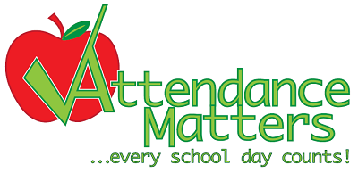 Attendance Reminder

As we near the upcoming holidays and school break, please plan ahead for absences.

Whenever possible, schedule vacations during designated school breaks, to limit your student from missing valuable classroom instruction, labs and collaborative group work.
To report an absence* call Skyview’s Attendance Office at 425-408-6810 (24 hour attendance line) or send a signed note, when your students returns to school. (*report within 48 hours - State Law RCW 28A225).
If your student will miss 5 or more school days, a pre-arranged absence contract form is required (available in the Attendance Office) as an agreement with teachers to make up assignments and to pre-excuse the absence.
Due to construction on campus, please allow extra time when dropping off or picking up your student.
For late arrivals to school or to arrange for an early dismissal, send a signed note on the same day your student is late or leaving early. Include student’s name, their ID number, date, time and reason for the absence.
Parents/guardians meet your student in the Attendance Office, with a valid photo identification. Releasing your student to someone other than a parent/guardian, requires written permission in advance.
It may not always be possible to dismiss students early during Assemblies, Advisory, Movement, Nutrition breaks, or the last 15 minutes of the school day, unless pre-arranged in advance with a note or calling the Attendance Office.
Enjoy time with family and friends over the upcoming holidays and school break!
Vicki Madsen, Attendance Office Secretary 425-408-6810 or 425-408-6819
Visit NSD Webpage: Click here for additional information and procedures.

2018-2019 Highly Capable Eligibility Process
The 2018-2019 Highly Capable Eligibility Process for services beginning in the 2019-2020 school year is underway! Information regarding this year’s process is posted on Northshore’s HiCap website. To access information regarding screening and assessment, please visit http://go.nsd.org/hicap.
6th & 7th Grade
Screening for students in 6th and 7th grade is November 19 – December 18. All students are included in the screening process; there is no nomination or registration of students.
For New to Northshore students, who were not enrolled during last year’s Naglieri Nonverbal Ability Test (NNAT3) screening, the NNAT3 will be administered during the school day, by a trained proctor.
For all other students who took the NNAT3 last winter, the HiCap Department will analyze student assessment data and Smarter Balance Assessment information.
8th Grade
For 8th grade students, the eligibility process is a portfolio review. Information regarding this process is available on the HiCap website (navigate to Eligibility and Testing/ Current Students/ Eighth Grade and Beyond).
All eligibility information will be shared by email and in backpack mail. So this is a great time to make sure your email contact information is up to date. Do this online through ParentVue or by contacting the main office at your student’s school.

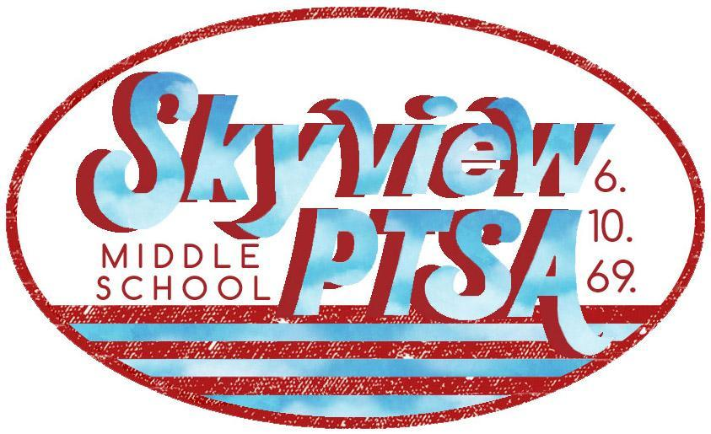 PTSA News
http://skyviewjuniorhigh.ourschoolpages.com/Home
PTSA GENERAL MEMBERSHIP MEETING & DIGITAL SAFETY 101
- Wednesday, January 16th
- Skyview PTSA is partnering with Northshore Council PTSA and Canyon Park MS PTSA to host speaker Jo Langford on Digital Safety at our next general membership meeting!
- Due to parking lot construction at SMS, these events will be held at Canyon Park Middle School.
- The PTSA meeting will be at 6:15pm in the Canyon Park Middle School Library.
- The Digital Safety presentation will be at 7pm in the Canyon Park Middle School Theater.
- Questions? Contact PTSA President Melissa Kline here.
SAVE THE DATE – CAREER DAY!
- We are currently planning for Career Day 2019 for Skyview Middle School and we need about 70 speakers to make this day a success for our large school. We are reaching out to you to see if you can share your experiences about your career and how you got there with our students.
- If interested in more info or becoming a panelist you can click here, or can email an inquiry to skyviewcareerday@outlook.com.
SKYVIEW PTSA PARTNERSHIPS
- Did you know your regular shopping at Amazon and Fred Meyer can earn money for Skyview PTSA?
- These beneficial partnerships are an EASY way to support your local school community, and add no additional fees/cost to your regular shopping.
- Great way to help during seasonal holiday shopping!
- Click here for how you can link up to help!
STAFF APPRECIATION – THANK YOU!
- With the help of generous donations from Skyview families, the PTSA Staff Appreciation Team was able to put on a yummy Appetizers & Mocktails lunch for SMS staff! Thank you to all who donated and helped make this Staff Appreciation Event such a great success!!!
AND FINALLY…
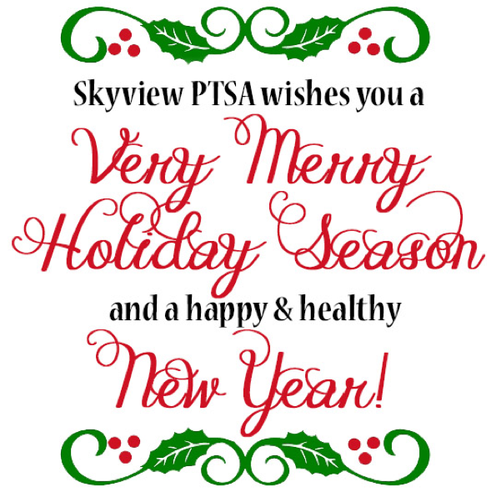

Music Booster News
Music Boosters is having a Dine In at MOD Pizza (Canyon Park location) on Thursday Dec. 13th ALL DAY! No flyer is required, just be sure to mention Skyview Music. See you there!

Our School office hours: 7:30am – 4:00pm
- - - - - - - - - -
Important School Phone Numbers and Emails:
Skyview Website: www.nsd.org/skyview
Main School Office 408-6800 dkinney@nsd.org
ASB and Athletics 408-6803 mjefferson@nsd.org
Attendance Office 408-6810 vmadsen@nsd.org
School Registrar 408-6818 kstaten@nsd.org
Health Room 408-6806 jcelms@nsd.org
Kitchen 408-6808
Transportation 408-7900

The mission of Skyview Middle School is to collaboratively educate and support students as they develop into lifelong learners by providing a nurturing environment where academic and personal excellence are achieved.
Dianne Kinney
Office Manager - Skyview Middle School
425.408.6801 direct/425.408.6802 FAX
To send large files including attachments, photos or documents:
https://mailfile.nsd.org/filedrop/dkinney@nsd.org

