Hello Skyview Families!
In this edition of the Skyview Family Newsletter, you will see:
- Important Upcoming Dates
- Information for Parents
- SBAC and MSP Testing Info
- ASB School News
- Notes from the Nurse
- Music Booster Dessert Night
- Attendance Office Reminders (Important during testing!)
- PTSA News

Important Upcoming Dates
- 4/26: Music Dessert Night (Cafeteria)
- 4/30: Girls Who Code (final meeting of year)
- 4/30: 4th Season Sports Photos after school
- 5/4: Choir/Band/Orchestra Middle School Solo/Ensemble Festival
- 5/6: SBAC Testing begins (see below for more info)
- 5/10, 5/11, 5/17, 5/18: Spring Musical Beauty and The Beast (7pm, with matinee performance on 5/11 at 2pm)
- 5/27: Memorial Day - No School

Information for Parents
- Did you know our daily announcements are online? You can find the daily bulletin on the Skyview website and subscribe to receive the daily announcements every day. Click here for the link to the daily announcements.
- Reminder: Every Wednesday for the remainder of the year is a full day with dismissal at 2:55pm except for June 5th.

SBAC and 8th Grade MSP Science Testing starts May 6th
The testing subject schedule is as follows (no testing on Wednesdays which will remain 1-6 full days):
- 5/6: English in Blocks 1, 2, 3
- 5/7: English in Blocks 4, 5, 6
- 5/9: English in Blocks 1, 2, 3
- 5/10: English in Blocks 4, 5, 6
- 5/13: Finish English in Blocks 1, 2, 3
- 5/14: Finish English in Blocks 4, 5, 6
- 5/16: Finish English in Blocks 1, 2, 3
- 5/17: Finish English in Block 4, 5, 6
- 5/20: Math in Blocks 1, 2, 3
- 5/21: Math in Blocks 4, 5, 6
- 5/23: Math in Blocks 1, 2, 3
- 5/24: Math in Blocks 4, 5, 6
- 5/28: Make up testing in periods 1-6
- 5/30: Science for 8th graders only in Blocks 1, 2, 3
- 531: Science for 8th graders only in Blocks 4, 5, 6
- 6/3: Make-up testing on Regular Blocks 1, 2, 3 schedule
- 6/4: Make-up testing on Regular Blocks 4, 5, 6 schedule
- 6/5: Make-up testing with periods 1-6 EARLY RELEASE
The lunch schedule will be posted around school and announced in classes. The 2019 SBAC Bell Schedule is as follows:
Period Time
1 or 4 8:10 10:05
Break 10:05 10:15
1st Lunch 10:15 10:45
2 or 5 10:50 12:45
2 or 5 10:15 11:15
2nd Lunch 11:20 11:50
2 or 5 11:50 12:45
2 or 5 10:15 12:10
3rd Lunch 12:15 12:45
Nutrition
Break 12:45 1:00
3 or 6 1:00 2:55

ASB News
4th Season Sports
4th Season Sports Photos will be taken after school on Tuesday April 30th - please be sure your athlete has their uniform to wear for the picture!
Yearbooks
The window for yearbook sales is closed. Yearbooks will be available to order during the last two weeks of school.
Spring Musical - Beauty and the Beast
Join us for the Spring Musical performance of Beauty and the Beast in the Skyview Cafeteria. Tickets are $10 adults/$8 with ASB card or Seniors will be sold at the door and online. More information on discount packages will be available soon! Showtimes are as follows:
- Friday May 10th - 7pm
- Saturday May 11th - 2pm
- Saturday May 11th - 7pm
- Friday May 17th - 7pm
- Saturday May 17th - 7pm

A Note from the Nurse

*8th grade parents*
On Thursday 4/18, you received an email with an attached Health Registration Form that needs to be returned to me at Skyview prior to your student transitioning to high school. Any time a student in NSD changes schools, we need to have an updated form on file, even if there have not been any significant changes. This is the best way to ensure that we have the most accurate information on your child's health conditions.
Please return that completed form to me prior to June 1st. You can send it in with your student, drop it off at the main office, or email it to me at jcelms@nsd.org.
Thank you for assistance in keeping your student's health information as accurate as possible!
-Jennifer Celms, RN, BSN
425-408-6806
jcelms@nsd.org

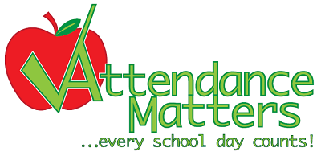SMS Attendance Office Reminders
With the SBAC testing approaching in May, it is very important that your student(s) are present and arrive on time to school, all day, every day.
Please talk to your student in advance, to determine which days they are scheduled for the SBAC tests, to avoid late arrivals or early dismissals from school on those dates.
Early Dismissal from school
Plan ahead for early dismissals whenever possible, as it is least disruptive to the classroom-learning environment, especially during the scheduled testing dates.
Send in a signed note to the Attendance Office, in the morning, on the same day your student is leaving early. Your student will receive a hall pass to show their teacher in the class they are leaving early, and then meet you in the Attendance Office at the planned time.
Students are not go out to the parking lot until parents/guardians or other authorized person(s) come into the Attendance Office, with a valid photo identification, to “sign-out”.
Also, allow extra time for the office to locate and dismiss your child from school; particularly during PE classes, Advisory/ Movement, Assemblies and other school-wide activities.
Early dismissals during the last 15 minutes of the school day, must be pre-arranged in advance.
Feel free to contact me or reach out to your student’s Counselor with questions concerning attendance or SBAC testing. Also, visit the SMS Website for additional information.
Thank you for supporting your student’s success at school, through their daily attendance.
Vicki Madsen
Skyview Middle School Attendance Secretary
425-408-6810 (24 Hour Attendance Line)
Absences must be excused by parents/guardians within 48 hours (State Law -RCW 28A.225.005)
Music Booster News

Join us Friday night April 26th for the annual Music Booster Dessert Night in the Skyview Cafeteria! Dessert Night is 4/26 from 7-9pm in the cafeteria. The night will open with our jazz band performing and the performances by our music and choir students. We also will have a raffle for some fabulous items including 4 concert tickets to Zoo Tunes!

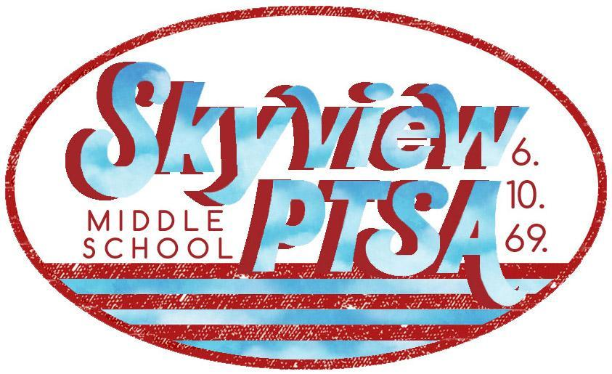 PTSA News
http://skyviewjuniorhigh.ourschoolpages.com/Home
STILL LOOKING FOR A PTSA PRESIDENT - Could this be the volunteer position for you?
- Contact current President Melissa Kline if you’d like to learn first hand what the job entails. You can ask questions without any obligation to volunteer!
- Email Melissa at melissareitbauer@hotmail.com.
TWO SPRING BREAK 2020 TRAVEL OPPORTUNITIES!
1) NEW YORK & WASHINGTON DC:
- Your student is invited on a once in a lifetime trip to Washington, D.C. and New York City!
- Students will experience first-hand the rich history of our nation by touring the world's most powerful cities. Students gain a deeper understanding of US history, the consequences of choices, and of their role in shaping America's destiny. This trip is an opportunity every American should experience.
- Further trip details can be found on the Skyview PTSA website here.
2) FRANCE and SPAIN:
- Come to an upcoming information meeting and learn more about this exciting adventure for current 7th & 8th graders and their parents/guardians.
- Wednesday May 1st, 6:30PM in the Skyview Library.
- If unable to attend and you’d like more information, please email to Marla Vaughn at mvaughn@nsd.org.
JOIN THE CAN DO 5K SKYVIEW TEAM - Grab a friend and your running shoes!
- Saturday April 27, 2019 - 19200 120th Ave NE Bothell, 98011
- The Can Do 5K is an event that celebrates all abilities - a great event for experienced runners and beginners alike!
- They offer a 5K Run/Walk and a 1 Mile Walk plus Kid Dashes. · Sign up & find more info at our website.
- Hope to see you out on the course representing the Skyview Eagles!
SKYVIEW PTSA MEETING - Wednesday, May 15th, 7:00pm, Canyon Creek Cafeteria
- Please come for a great night of celebration, elections & helpful info!
- PTSA will present the Outstanding Educator, Outstanding Advocate, & Golden Acorn awards.
- PTSA general membership will vote on the 2019-2020 budget for how to use funds donated by the generous members.
- We will be electing your PTSA officers for the 2019-2020 year.
- Grab a friend and come say hello at the meeting! Hope to see you there!
8th GRADE PARTY - New details are NOW available on our website!
- Date/Time: June 14, 2019 6:30pm – 10:30pm
- Location: McMenamins Anderson School's Haynes Hall.
- Cost: $45/student and includes dinner, dancing, entertainment and photo booth!
- We look forward to hosting a FUN celebration to honor Skyview's 8th Grade class!
- Please check out the website for more info, permission slips and FAQ's.

Our School office hours: 7:15 am – 3:45 pm
- - - - - - - - - -
Important School Phone Numbers and Emails:
Skyview Website: www.nsd.org/skyview
Main School Office 408-6800 dkinney@nsd.org
ASB and Athletics 408-6803 mjefferson@nsd.org
Attendance Office 408-6810 vmadsen@nsd.org
School Registrar 408-6818 kstaten@nsd.org
Health Room 408-6806 jcelms@nsd.org
Kitchen 408-6808
Transportation 408-7900

The mission of Skyview Middle School is to collaboratively educate and support students as they develop into lifelong learners by providing a nurturing environment where academic and personal excellence are achieved.
Dianne Kinney
Office Manager - Skyview Middle School
425.408.6801 direct/425.408.6802 FAX
To send large files including attachments, photos or documents:
https://mailfile.nsd.org/filedrop/dkinney@nsd.org

