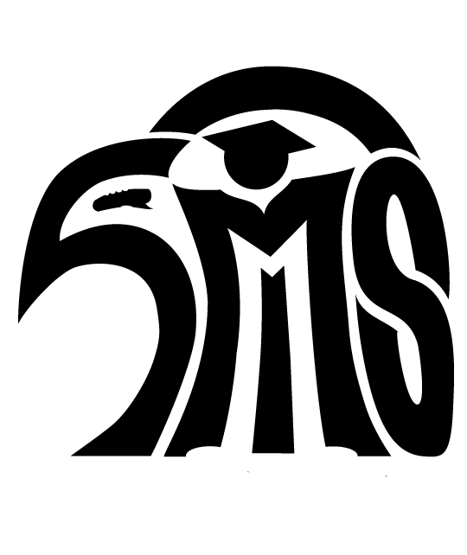
Revised SMS Agreement for use of Personal Technology Devices
2018-19

Students may bring personal technology devices (such as smart phones, digital music players, etc.) to school only after they have this signed, dated agreement on file. This agreement outlines acceptable use and storage of personal technology devices and handling of device abuse, theft, and loss.

Use of devices:
Personal technology devices can be useful in an educational setting when used appropriately. However, unless the device is being used in class with teacher approval, all personal technology devices must be silenced and put away during class time. Personal technology devices shall not be used at any time on campus without permission of a staff member. Cell phones should be kept out of sight at all times unless being used with staff member permission. We recognize the importance of students and families to be able to communicate. Students may ask a staff member for permission to use their student cell phone for family communication. Students may also go to the office to use their phone for family communication.

Personal technology devices must not violate the Northshore School District Acceptable Use standards as outlined in the Rights and Responsibilities Handbook Concerning Student Conduct. In particular, there will be no harassing, abusive, or threatening activities (cyberbullying) when using personal technology devices. Students will have access to the district’s network through the BYOD (Bring Your Own Device) program. Also, unless it is for a classroom assignment, students will not take pictures or video of other students or teachers.

Using personal technology devices is a privilege and students should behave responsibly. If the use of such a device causes a disruption to the learning environment anywhere on campus, the student is subject to the discipline outlined below.

Abuse of personal technology privilege:
- First violation of the personal technology device agreement will result in an infraction.
- Second violation of the personal technology device agreement will result in an after-school detention.
- Third violation will result in a 2-hour Saturday School.
- Fourth violation will result in a 4-hour Saturday School.
- Further violations will result in school suspensions.

Theft and loss of personal technology devices:
With this agreement, parents and students assume the risk of loss or theft of their personal technology devices. The school provides secure lockers in the academic building and locker rooms. Students shall not share lockers with other students or their locker combination with other students. Students shall not “rig” their lockers for ease of access. If theft occurs from an unsecured locker, the school will not investigate.

Signatures of student and parent/guardian below are an agreement to abide by the preceding personal technology rules.

Print Student Name: ____________________________________________________________

_____________________________________ ___________ __________________________________ _____________ Student signature Date Parent/Guardian signature Date

- - - - - - - - - - - - - - -
For office use:

1st Infraction Date __________________ Infraction

2nd Infraction Date __________________ Detention

3rd Infraction Date __________________ Saturday School (2 hours)

4th Infraction Date __________________ Saturday School (4 hours)

